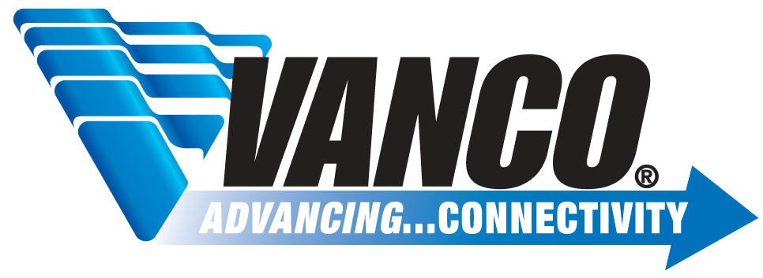

New RMA process for Audio/Video Distribution products with a Vanco Serial #:

- Before distributing request RMA for products, Vanco would like an opportunity to assist the installer in implementing the item
- Vanco Tech Support troubleshoots issue with dealer/installer
- If resolution is not found, then Vanco issues Service Tag # (ST-MMDDYY-1)* to dealer/installer IF PRODUCT IS STILL UNDER WARRANTY, this is verification that item can be returned to Vanco and credit or replacement unit will be given to distributor for defective item (this ensures all claimed non-working or defective products went through Vanco troubleshooting process before authorization to return item is granted)
  - Terms of return:
    - All items returned must be in resalable condition – otherwise return not accepted (i.e. scratches, dents, physical damage etc.)
    - No missing parts (i.e. missing power supply etc.) – otherwise 15% restocking fee
    - Original box included and not damaged – otherwise 15% restocking fee
- RMA is granted and distributor sends back claimed defective unit to Vanco
- Vanco tests and verifies unit is defective (RA QC Test form is generated and saved on Network under RA Forms folder)
6. Vanco issues credit to distributor in the form of a Return Material Advice form, communicating to distributor that refund amount can be deducted from next check remittance. Restocking fee applied if needed. Distributor has 60 days to collect RMA credit.

*The Service Tag # is a form that is sent to the dealer/installer to be submitted to the distributor, this form is verification that the RMA can be issued and the product can be returned to Vanco.

