EVSP24VW
Connecting Multiple Units

The EVSP24VW supports daisy chaining and cascade modes to support larger video wall configurations. To connect multiple units and create large video walls, you will need to separately configure each unit Device ID using the software found on www.vanco1.com, using the RS232-CTL port on the back of the unit. It is important to note that control of multiple units can ONLY be done using RS232.

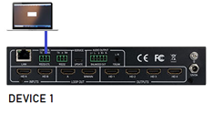
- Connect the first main unit to a computer using the RS232-CTL port and the provided RS232 cables.
- Open the EVSP24VW software found under the downloads tab of the product page at www.vanco1.com.
- Click UART, select the correct Comport from the dropdown menu, and select Connect.
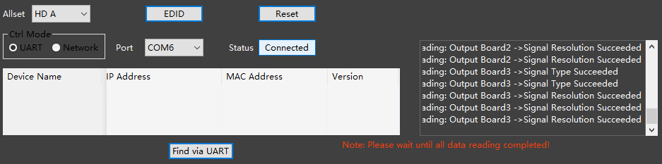
- Once connected to the software, go to the VIDEO WALL tab.
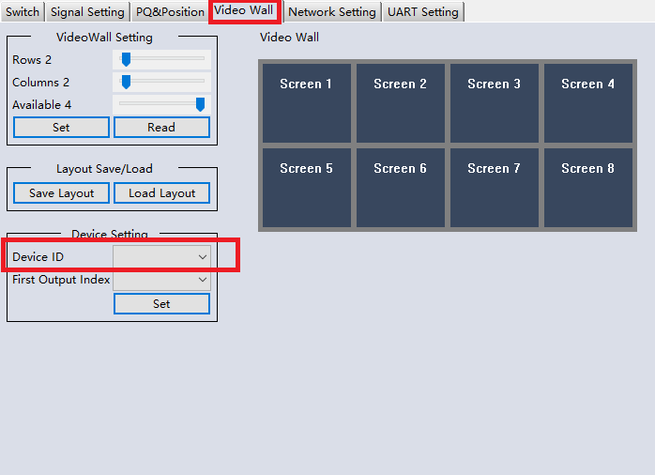
- The Device ID correlates to each unit. Device 1 would have a Device ID of 1, Device 2 would have a Device ID of 2, Device 3 would have a Device ID of 3, etc.
- The First Output Index relates to the FIRST OUTPUT/DISPLAY NUMBER each unit would start with and provide video for. For example, Device 1 would have an Index number of 1 (starting with Screen 1 from the image above) and provide image for screens 1-4. Device 2 would have an Index number of 5 (starting with Screen 5 from the image above) and provide images for screens 5-8.
- After setting the ID and Index for each unit, click SET.
- Go back to the SWITCH tab and disconnect the software from communicating to the first EVSP24VW.
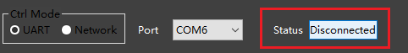
- Physically disconnect the 3-pin cable from the first EVSP24VW and connect the second unit to the computer using the RS232-CTL port on the unit and the provided RS232 cables and to connect to the software.
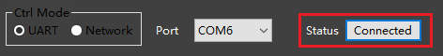
- Again, once connected to the software, go to the VIDEO WALL tab to set the ID and First Output Index. Repeat for additional units.
- Go back to the SWITCH tab and disconnect the software from communicating to the first EVSP24VW.

- Now that the units are configured, it is time to connect the units together. Using the provided RS232 cables, connect the first unit from the CONTROL RS232 port, to your computer or 3rd party control system.
- Next, using the provided 3-pin terminals, connect the RS232 port of Device 1 to the CONTROL RS232 port of Device 2 as shown in the diagram below.
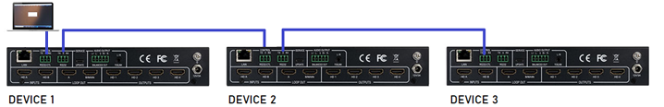
NOTE: Make sure the TX pin from Device 1 is connected to the RX pin on Device 2, and the RX pin from Device 1 is connected to the TX pin on Device 2.
- Once all physical connections are made, open the EVSP24VW software, Connect, and you will see all available displays.
